®

Promise South Salt Lake works in partnership with United Way and many other organizations to implement specialized common agendas and program maps based on what the data tell us, to provide model/evidence-based curriculums, expanded learning & positive youth development opportunities that support academic, physical, civic, social, and emotional youth success. Activities in South Salt Lake include high intensity, literacy-focused afterschool programs; structured recreation and service opportunities; intentional reciprocal cultural opportunities; and a broad range of enriching experiences that utilize a cradle to career continuum that improves educational and developmental youth outcomes. Our work is accomplished in the 14 South Salt Lake Neighborhood Centers and throughout the community. We articulate our work as promises that represent our highest hopes for our community.
Based on very specific research and models of other successful communities, Mayor Wood and the Promise South Salt Lake Leadership Team formulated our goals—considering the work that is being done in other high achieving communities, but created with South Salt Lake children, families, residents, and seniors in mind.

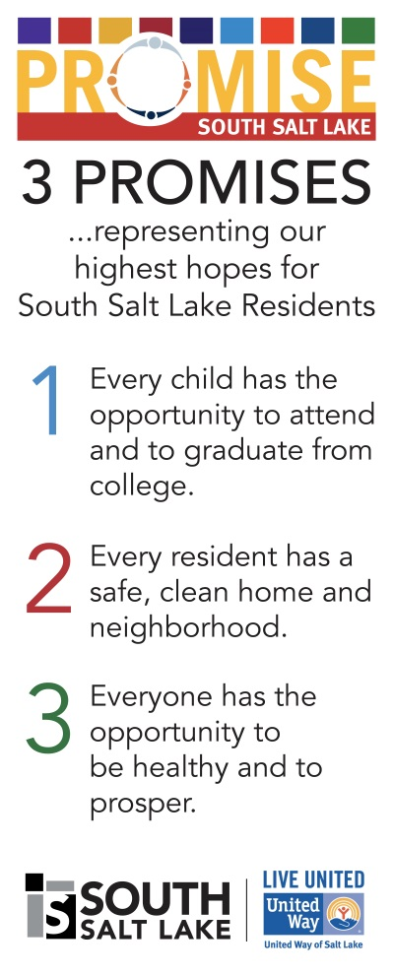

The followings are some ways to show kids you care and to illustrate for you the importance of how we interact with the children and youth in Promise South Salt Lake.

- Acknowledge them
- Love them, no matter what
- Become their advocate
- Learn their names
- Praise more; criticize less
- Expect their best; don’t expect perfection
- Empower them to help and be themselves
- Set boundaries that keep them safe
- Suggest better behavior when they act out
- Nurture them with good food, good words, and good fun
(Source: Healthy Communities, Healthy Youth)

Our children and youth need people in their lives who recognize their achievements, share their triumphs and struggles. Be honest, fair, kind and considerate; help our community’s youth to feel secure. Model for them what it is to behave appropriately and be a friend. Youth should learn from our program that they are a worthwhile person who should be treated with respect and who treats those around them with respect.

