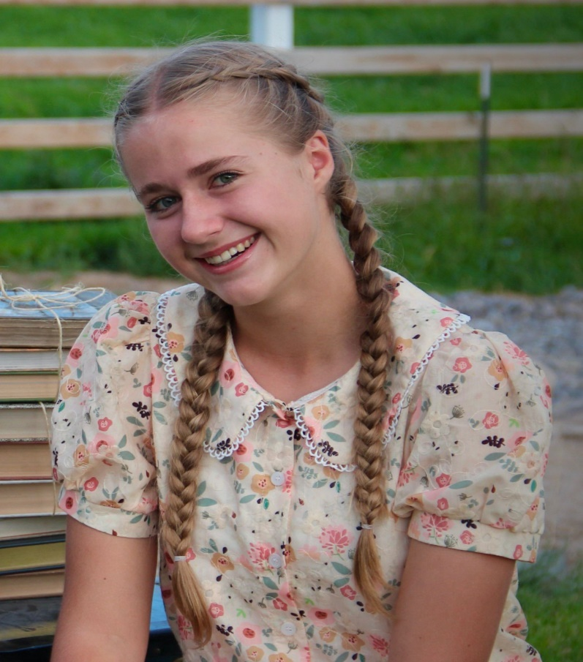

HIGH SCHOOL WINNER

Andilusia Ruth Manwaring 12th Grade Copper Hills High School

Biography

Andilusia Manwaring is a Senior at Copper Hills High School. She runs cross country and track as a top varsity athlete. She is also in her school's concert choir, National Honors Society, FFA, and Spanish Club. She loves to play piano, paint, draw, snowboard, ski, hike, read, and photography. Most importantly she loves to eat ice cream. She also considers herself a dedicated "swiftie".

After she graduates, she plans to attend college for a year then serve a mission for The Church of Jesus Christ of Latter-day Saints.

Essay

Why I am Proud of my Military Veterans!

I am proud of both my military veterans – my mom and dad. They are actively serving our state and country as colonels in the Utah Army National Guard. I am proud of them for their selfless sacrifice, their good example to me, and the reasons they don’t do it for.

Freedom isn’t free. I know the truth of this statement first-hand. From tiring work hours to being deployed on the other side of the world for months or even years, I clearly see that the freedom of this country was paid for by the blood, sweat, and tears of men and women. They risk their lives for others without expecting any sort of payment, recognition, or award. They do it because they love our country, we live in with the freedoms we’re allowed and want to see it and its people safe from harm. I know specifically that my dad didn’t want to miss many years of my life as I progressed from a little girl to an adult. But he had to sacrifice this because he knows our country can’t be safe without the heavy cost included. Both my mom and dad have missed birthdays, sporting events, award ceremonies, and important moments of our lives because they believe in a free America where us kids can live and thrive in. Because of my parents’ constant sacrifice, I can make my own choices and pave my own future.

I am grateful I grew up with a love and appreciation for my country due to my parents’ example. Most people don’t realize how good we have it compared to other places in the world. Not everyone in the world can say that they feel safe, much less have the freedoms and voice that we have. Freedom is constantly taken for granted and I’m grateful I know better than to do the same.

What means more to me is not why they do it, but more so what they don’t do it for. They don’t do what they do for money, power, or glory. Their reasons are unselfish and focus instead on the needs of others. Being a senior in High School, many students are starting to choose their career paths. As I converse on this topic with others, I find people often focus on what jobs will give the highest pay or provide the most convenience to them personally. Not only are they looking past the importance of doing what makes them happy, but how their career can make others happier too. I am proud that my parents were able to look past other career options that would be far more convenient or benefiting and choose something that makes them happy while also importantly seeing to the needs of our state and country. As a daughter of military veterans, I know it’s definitely not easy or convenient. But then again, if it was easy, everyone would do it.