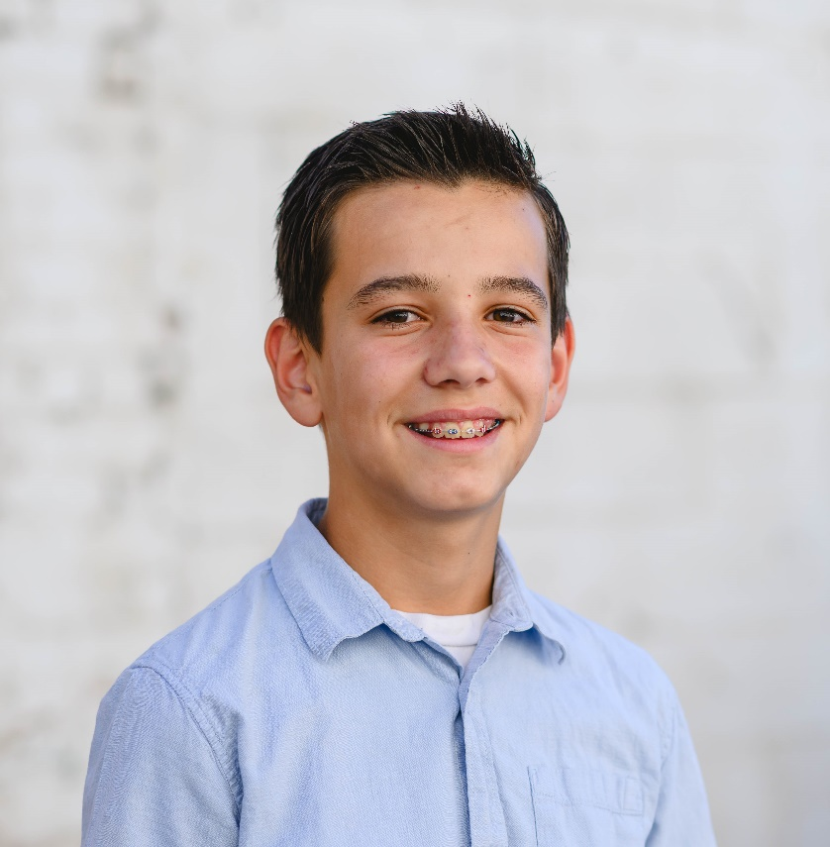

JUNIOR HIGH SCHOOL WINNER
Ethan McFate 8th Grade Lakeridge Junior High School
Biography
My name is Ethan McFate. I am currently an 8th grade student at Lakeridge Jr. High in Orem, UT.
I haven’t lived in Utah all my life, I was born in Wooster, Ohio to Aaron and MaryAnn McFate and like many military kids have moved an impressive and depressive 11 times. Through all of those moves and all the changes each has brought I have learned to overcome and adapt. I have played bass in the school orchestra for 3 years, am taking my second year of French and am an athlete at heart. I have participated in running clubs, multiple sports including tackle football where our team just played at the state championship, and I also won my school spelling bee. I am active and spend most of my time outside playing sports in the street with our neighbors and my brothers and sister. I love to read and when I’m not playing sports you will probably find me sitting in a comfortable spot devouring a book.
I have had opportunities to lead and serve with my local youth group as well as with my school National Junior Honor Society. When I grow up, I dream of becoming many things: an author, a teacher, an athlete but most of all I want to bring honor to those who came before me and live up to the life that has been provided for me through their sacrifices.

Essay
I come from a family that almost all the men, and some of the women have served or are still serving in the military. My great-grandpa Henry Nicholes was in the navy as an assistant to many important generals in World War ll. My other great-grandfather Frank Hood served in the US Army during the Korean war. My uncle Joel is currently serving in the Marine Corps. My uncle Steven is currently serving in the US Army, and my Uncle Daniel was in the Navy. Both my parents served in the military as well. I feel like these people and their examples most influenced me.
My great-grandpa Nicholes was still alive when I was a tiny child. He lived his life so peacefully and simply. He didn’t seem like he could have been in the military because he didn’t carry any outer wounds. He has created the happiest memories I have today. Whenever I would visit him, he would greet me by lifting me up by my ears and would swing me around. He did it in some way so that it wouldn’t hurt my ears when they were being pulled.
My uncle Steven always seems to be able to put a positive spin on things. He is always so happy and relaxed. He’s always patient and willing to hear everybody’s part of the story.
My uncle Joel has always been a good example to me. He joined the Marines after getting his master’s degree. He has done 4 tours of duty, including Iraq, and has been part of several international law think tanks all over the world. He hopes to continue influencing military law.
Now my mom probably has influenced me the most. She might not have gone through actual combat, but she does have an amazing story. When she was still in basic training, she broke her hip. Even though she broke her hip, she still completed all her training. She still did the pushups, and she still put in the effort even through all her pain. What inspires me about her story is that she had the mental capability to get through all the toughness of basic training, and not give up. She also didn’t blame anyone because she was hurt. She just told herself to push through it.
And then there’s my dad. He joined the Army when he was 18 because he wanted to fight for his country and for the future generations. While he was in the US Army, he got deployed to Iraq twice and was preparing to go to Afghanistan just after my first birthday. From what I have been told he was always happy and joked all the time. His favorite phrase was “It is what it is.” My dad is not alive today, but if he was, I’m sure he would be proud of me for writing this and glad to know that I recognize his sacrifice and courage for me.
Submitted by: Ethan McFate
Lakeridge Junior High School
8th Grade

