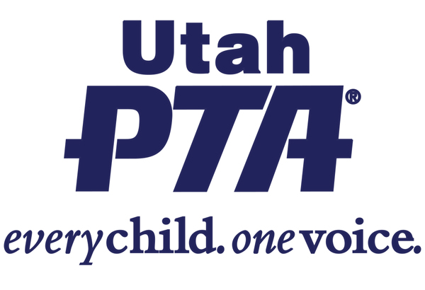
HB 417- School Materials Amendments (Rep. Ken Ivory)
This bill criminalizes providing sensitive materials to children in schools.

Utah PTA’s position on HB 417 is OPPOSE with COMMENT

Background:
- This bill is part of a larger social and legislative movement to protect children from sensitive materials. However, this bill penalizes and criminalizes educators. PTA has taken a position of OPPOSE with Comment.
- The Comment is: Utah PTA is opposed to children's exposure to sexually explicit materials. Teachers and librarians work hard to support their students and provide them with appropriate materials. Putting criminal penalties on teachers for providing materials to their students is poor policy and will have a chilling effect on recruiting and retaining exceptional educators.

What the bill does:
- Requires LEAs to use the “least sexualized, violent, or vulgar material that communicates the principles” being taught. This could be difficult since the educator may not be aware of every possible material related to that principle.
- LEAs must inform parents of every material that is available to student access that has any sensitive material AND each material that a student borrows- including all materials in the building. This would be a significant amount of work for educators.
- Any educator found with materials in violation of the rule will be subject to a $500 fine and AT LEAST 30 days in jail. This could have repercussions for their teaching license.
- This would apply to any material with “a description of illicit sex or sexual immorality or nude or partially denuded figure”. Educators are concerned about picture books with shirtless characters, the works of Shakespeare, The Great Gatsby, 1984, Shel Silverstein books, and many other materials.
- Prohibits LEAs from restricting public display or recitation of texts in public meetings if the image/text is an excerpt from material that is available to students in the LEA- even if there are children present in the meeting. Some titles may be appropriate for High School students but not for elementary students.
- Removes governmental immunity from personal lawsuits from educators.

What the bill doesn’t do:
- Trust educators to choose materials that meet the needs of their students and to provide alternative choices when there is a parental concern.
- Provide funding to replace banned materials.
- Leave curricular control to Local School Boards and schools.

Questions to ask your legislator?
- Shouldn’t material selection be a local decision?
- How will this affect our ability to recruit and retain exceptional educators when there is already a teacher shortage?

Share your story:
- How would this impact your student’s education?
- How would this impact your student’s teachers?

Other items of interest:
- There are many bills this session that cover topics that should be decided on the local level.

