Utah PTA's mission is to make every child's potential a reality by engaging and empowering families and communities to advocate for all children.

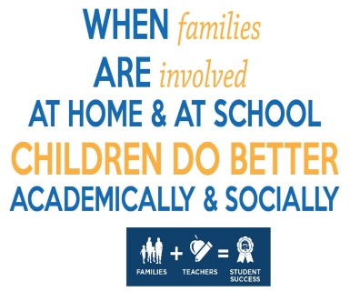
PTAs play an important role in promoting family engagement in schools and communities. The National Standards for Family-School Partnerships can be used by PTAs as a framework for thinking about, structuring, and assessing family engagement.

Each of the standards are listed below and have a place to make a goal for your PTA/PTSA to use that standard. You can make a goal in each standard or focus on a few.

Standard 1: Welcoming all families into the school community—Families are active participants in the life of the school, and feel welcomed, valued, and connected to each other, to school staff, and to what students are learning and doing in class.

Goal:______________________________________________________________

Standard 2: Communicating effectively—Families and school staff engage in regular, two-way, meaningful communication about student learning.

Goal:______________________________________________________________

Standard 3: Supporting student success—Families and school staff continuously collaborate to support students’ learning and healthy development both at home and at school, and have regular opportunities to strengthen their knowledge and skills to do so effectively.

Goal:______________________________________________________________

Standard 4: Speaking up for every child—Families are empowered to be advocates for their own and other children, to ensure that students are treated fairly and have access to learning opportunities that will support their success.

Goal:______________________________________________________________

Standard 5: Sharing power—Families and school staff are equal partners in decisions that affect children and families and together inform, influence, and create policies, practices, and programs.

Goal:_______________________________________________________________

Standard 6: Collaborating with community—Families and school staff collaborate with community members to connect students, families, and staff to expanded learning opportunities, community services, and civic participation.

Goal:_______________________________________________________________

