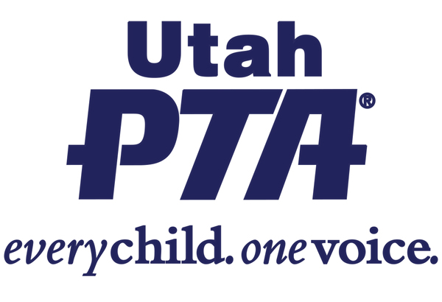
SB 104 - Childhood Device Protection Act
(Senator Todd Weiler, Rep. Susan Pulsipher)
This bill protects children from possible exposure to pornography.

Utah PTA SUPPORTS SB 104

Background:
- This bill is part of a larger social and legislative movement to protect children from the harms of pornography and sexual exploitation.
- Current research shows that pornography exposure contributes to poor mental health in children and teens.
- This bill aims to protect children from harmful media and individuals that are seeking to exploit them.

What the bill does:
- Requires a tablet or a smartphone (a device) manufactured on or after January 1,2025, to automatically enable a filter upon device activation by a minor;
- Requires the filter enabled for minors at activation to:prevent a minor user of the device from accessing material that is obscene; and allow adult users and parents or legal guardians to deactivate and reactivate the filter with a password;
- Permits the attorney general to bring civil actions against manufacturers of device that do not comply with this bill;
- Permits private civil actions by parents and guardians of minors against manufacturers and others who violate provisions of this bill;
- Makes it a criminal offense for any person, with the exception of a parent or legal guardian, to enable the removal of the filter on a device in the possession of a minor.

What the bill doesn’t do:
- Retailers will not be sued for noncompliance with this bill.

Questions to ask your legislator?
- Do you support protecting Utah’s children against accidental or intentional exposure to obscene material on a smart phone or device?
- Do you support holding manufacturers accountable for violating laws that protect children from being exposed to obscene material on their devices?

Share your story:
- How would this impact your life?
- How have you seen this issue in your life?

