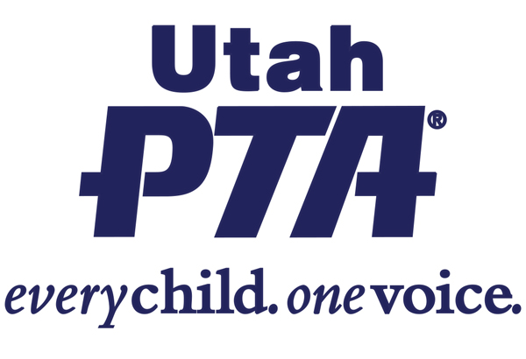
SB141 - FAMILY HEALTH SERVICES AMENDMENT
(Senator Luz Escamilla)
This bill Informs eligible individuals about child and maternal health
services offered by state agencies, like home visits.

Utah PTA SUPPORTS SB141

Background:
- We know that support in early childhood has a major impact on the health and well-being of a child. We also know that as parents have a more positive interaction with their access to healthcare, parents are more likely to seek out the support they need.
What the bill does:
- This bill allows eligible individuals to be informed about child and maternal health visits, offered by state agencies, like home visits.
What the bill doesn’t do:
- This bill does not force parents to choose only providers that they’ve been given information about.
- This bill does not create any new health programs

Questions to ask your legislator?
- Do you support access to more child and maternal health services?
- If so, do you support the Department of Family Health being responsible for sharing that information with eligible participants?
Share your story:
- Would this impact your family? If so, how?
- How do you think more access to health care would benefit your community?

