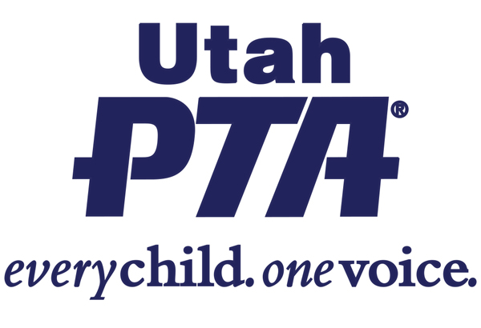
SB 44 - Alternative Education Scholarship Combination
(Senator Lincoln Fillmore, Rep. Candace Pierucci)
This bill combines the Carson Smith Scholarship and Special Needs Opportunity Scholarship Programs

Utah PTA OPPOSES SB 44

Background:
- This bill combines 2 existing scholarship programs into one, renames it the Carson Smith Opportunity Scholarship Program and specifies that it will be administered by a scholarship granting organization.
- The Special Needs Opportunity Scholarship was created in 2020 to provide private school scholarships for students with disabilities.
  - In 2022 the program was expanded to include siblings of students with disabilities as eligible scholarship recipients.
  - In 2023 the program was expanded to include transportation as an eligible expense.
  - In 2024, this bill expands eligibility to include home school and preschool students.
- The Carson Smith Scholarship Program was created in 2005 to provide private school scholarships to K-12 students with disabilities.
- Under the new combined program, these scholarships are intended to help students with disabilities (and their siblings) pay for eligible expenses such as private school tuition, materials, curriculum, technology, etc.
What the bill does:
- Allows donors to the scholarship fund to receive a tax credit for the full amount of their donation.
- Allows recipients to be awarded up to 2.5 times the Weighted Pupil Unit (WPU) amount.
- Allows the scholarship granting organization to spend up to 5% of donations on administrative costs and up to 3% on marketing and fundraising.
- Keeps tax money from going into the funds supporting public education.
- Requires scholarship applicants to:
  - Acknowledge that a private school may not provide the same level of disability services that are provided in a public school.
  - Deny their rights to services issued under the Individuals with Disabilities Education Act (IDEA).

What the bill doesn’t do:
- Does not require scholarship recipients to report on how money was spent
- Does not require recipients to report on how the funds are helping the student to progress.
- Does not follow up to understand if the funds are accomplishing the intended purpose.

Questions to ask your legislator?
- Why will the program be administered by an outside scholarship granting organization instead of by the Utah State School Board of Education?
- How will you know if these scholarships are actually helping students with disabilities?
- Why is there no accountability or follow-up on how these taxpayer funds are spent?
- How many students are these scholarships serving?

Share your story:
- Do you have a child with a disability?
- What has your experience been with getting IDEA services for your child in the public school or other settings?

