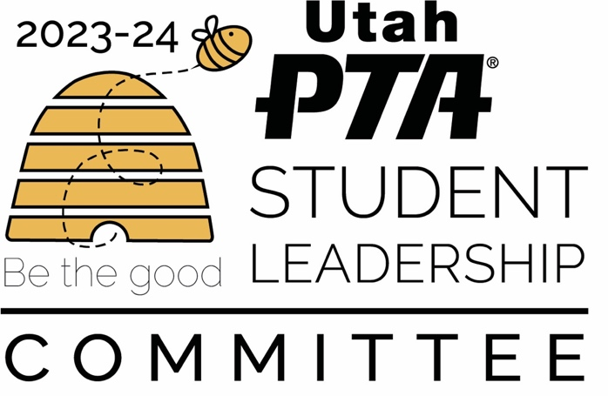

Meeting Dates:
Meetings Held at Daybreak Library from 6:30-8pm. Zoom Option Available

- September 12th (change due to September 11th activities at the library)
- October 16th (change due to October 9th being Columbus Day and library will be closed)
- November 13
- December 11th
- January 8th
- February 12th
- March 11th
- April 8th
- May 13th

Important Dates to Remember:
- January 27th, 2024: Student Leadership Conference
- February 8th and 13th : PTSA Day at the Capitol
- April 27th: State Battle of the Bands

