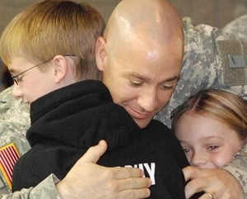
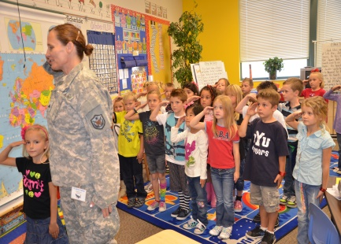
UTAH PTA SUPPORTS OUR
MILITARY FAMILIES
Kathy Allred
Utah PTA Military Family Specialist
As Utah PTA’s Military Family Specialist, I provide opportunities, training and resources to raise awareness, build support, and help our military families and children meet the unique challenges they face! We have the opportunity to recognize military children and youth for their character, courage, sacrifice, resilience and service.
Did you know? In Utah we have over 18,000 children who have one or more parents, step-parents, siblings, or extended family members on full-time duty in the military, including members of the National Guard and Reserves on active duty.
What are the challenges our Military Children face? They face frequent relocations, educational inconsistencies-different school systems, adjusting to new neighbors and communities, leaving friends and making new friends, family separations, grandparents as care givers, disability or loss of family member and many other challenges.
What can PTA do? Communicate with military families, educate the community, advocate -- to eliminate nation-wide educational inconsistencies, and be a source of information and support.
How do we reach and include them? Identify them, and find out who they are. Invite them, welcome them, and ask them to participate. Inform them of events and programs and communicate with them. Involve them, because volunteering is what they do. Include them, because no job is too small to use their skills.
How does PTA benefit Military Children and Families? PTA supports them by reaching out to them and helping them. PTA sustains them by being their friends and including them. PTA leaders and members recognize and honor their sacrifice and acknowledge their service with patriotic activities and programs.
Upcoming Utah PTA Military Family Events? November is the Month of the Military Family! Utah PTA celebrates this month by partnering with the Utah National Guard at their Veteran’s Day Concert, on an evening on or around Veterans Day at 7 pm, in the Tabernacle on Temple Square. Every year we hold an essay contest for military children with the theme, “Why I am proud of my Veteran!” At the concert our winners from elementary, middle/junior high and high school are honored!
If you have any questions or want more information, please contact Kathy Allred, at Utah PTA 801-261-3100, or at www.militaryfamilies@utahpta.org .

