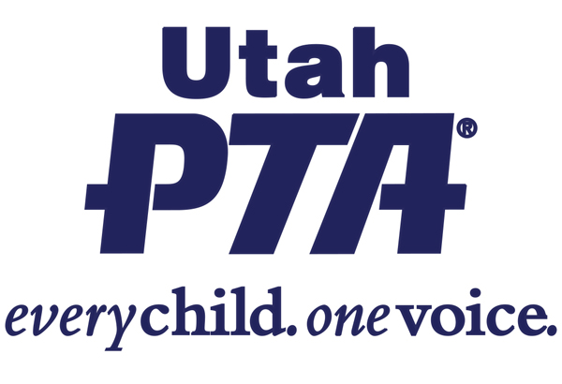
H.B. 71 - BEHAVIORAL HEALTH CRISIS RESPONSE
(Rep. Eliason, Sen. Thatcher)
Receiving centers and mobile crisis outreach teams

Utah PTA SUPPORTS H.B. 71 - **Priority Bill**

Background:
- This bill authorizes grants for the development and expansion of mobile crisis outreach teams and rural behavioral health receiving centers. This would strengthen Utah’s behavioral health crisis response and help expand access to services in rural Utah.
What the bill does:
- The bill would secure funding to add two additional crisis centers in rural Utah preventing those experiencing a mental health crisis from unnecessarily being taken to jail. Instead they can be taken to a place where they would receive help.
- The bill would fund more mobile crisis teams which will allow people experiencing a behavioral health crisis to be met with first responders prepared to help them, instead of immediately going into the hands of law enforcement, who are often not equipped to deal with a behavioral health crisis.

What the bill doesn’t do:
- It does not address long-term mental health strategies, prevention programs, or other systemic aspects of mental health care.
- It does not require the use of mobile health crisis teams rather than first responders

Questions to ask your legislator?
- How can we as citizens contribute to ensuring the success of these programs in our area? Are there specific actions or advocacy efforts that would be particularly helpful?
- From your perspective, what immediate benefits do you foresee for our community if this bill is successfully implemented?

Share your story:
- Has your life or your family’s life been affected by this issue?

- How would access to a mental health crisis mobile team affect your family’s life?

