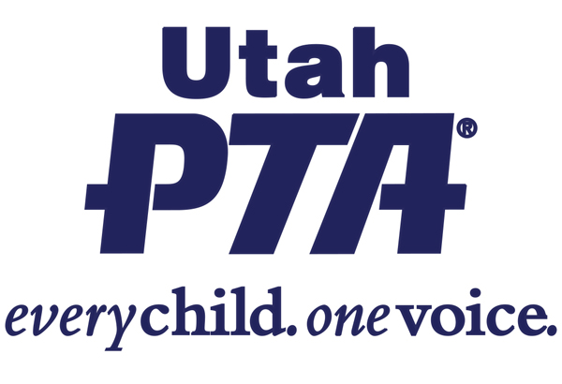
HB 201 - Traffic Enforcement Amendments (Rep. Brett Garner)
This bill creates the Speed Safety Camera Pilot Program

Utah PTA SUPPORTS HB 201 - **PRIORITY Bill**

Background:
- In May 2023 a local member brought concerns forward because of a pedestrian fatality at their school. The Utah PTA Safety Commission started a pedestrian safety work group to address our concerns with children walking safely to school.
- Several other PTA members state wide have had this as a concern and joined the work group. Rep. Garner has assisted this work group, he helped us with research and brought this bill forward at our request to help with enforcement of speeding in school zones
- This pilot program allocates funding for up to five speed zones to implement camera technology for improved enforcement capabilities.

What the bill does:
- This bill creates the Speed Safety Camera Pilot Program, it amends restrictions on the use of a speed safety camera for traffic enforcement.
- It helps to enforce speed limits in school zones.

Questions to ask your legislator?
- Will you support this bill? Do you have ideas about how to increase enforcement of traffic laws in school zones and safe walking routes?
- Please contact Rep. Kay J. Christofferson at kchristofferson@le.utah.gov or 801-592-5709 and ask to get this bill on the agenda for the House Transportation Committee.

Please help us get HB 201 Traffic Enforcement Amendments passed.

