Thank you for putting the “T” in PTA

Teacher Name
is a proud teacher member of the

2021-2022 Milton Elementary/Middle School PTA
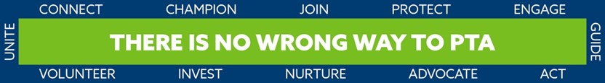

Type PTA Name Here
