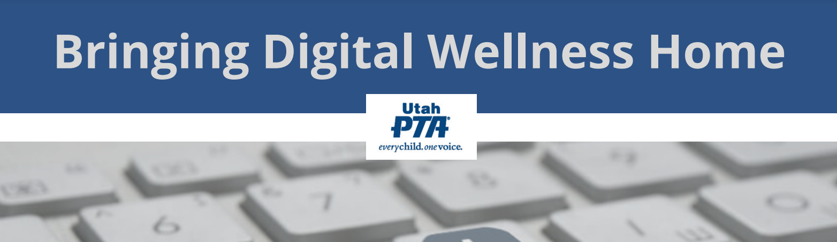

PTA's Bringing Digital Wellness Home Series
Week 1: Start with Your Center
Activity 1: Write about one of your values

Optional activity: Keep writing each day about your value (~5 minutes)
Optional activity: Create or find a visual reminder of your value

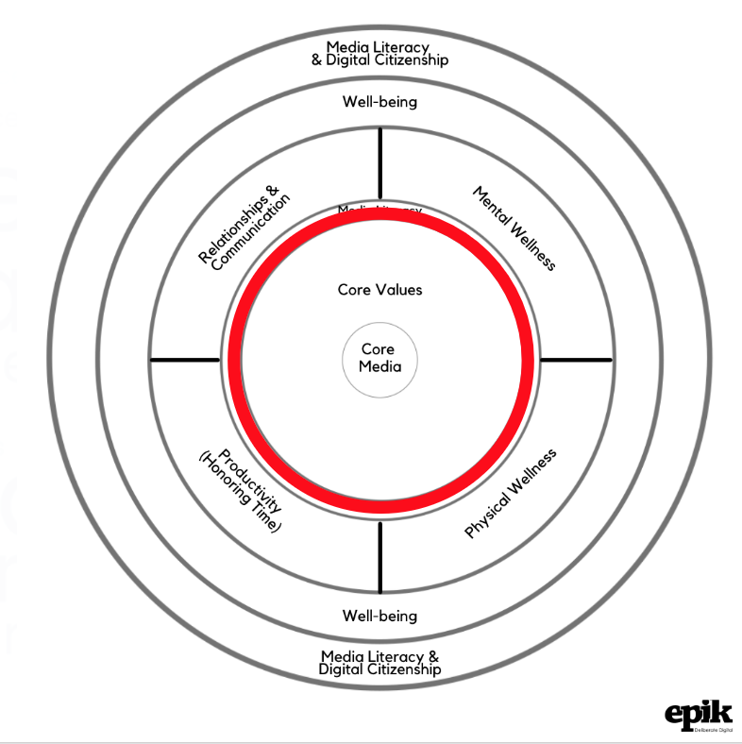

Activity/Invitation:
- Write down three attributes you would like to develop, focus on, or have in mind during this series.
- Write about one.

Principle:
Digital Wellness really starts here. It's easy to think that Digital Wellness is about managing technology, but it's really about aligning technology use with values and goals. It's about using technology in ways that magnify the kind of person you want to be.

Information and Instructions:
As we start this experience of exploring Digital Wellness together (or what EPIK calls Digital Centeredness), your first invitation is to take ten minutes to write about one of your values. Just ten minutes can have a significant impact!

Dr. Kelly McGonigal (psychologist, researcher, Stanford professor): “It turns out that writing about your values is one of the most effective psychological interventions ever studied. In the short term, writing about personal values makes people feel more powerful, in control, proud, and strong. It also makes them feel more loving, connected, and empathetic toward others. It increases pain tolerance, enhances self-control, and reduces unhelpful rumination after a stressful experience. In the long term, writing about values has been shown to boost GPAs, reduce doctor visits, improve mental health, and help with everything from weight loss to quitting smoking and reducing drinking. It helps people persevere in the face of discrimination and reduces self-handicapping. In many cases, these benefits are a result of a one-time mindset intervention. People who write about their values once, for ten minutes, show benefits months or even years later.” [from The Upside of Stress*]

We often define values by things outside of us, things that matter to us, e.g., "I value my family." "I value water conservation." "I value my faith." "I value service." "I value freedom." "I value health." This approach to values is valuable, to be sure.

Here, we're inviting you to engage in this exercise with a different and very specific lens. We'll be talking about priorities later in the series when we talk about productivity & honoring time – about things that matter to us. These impact decisions we make about how we use technology as well. But in the end, technology is a shifting thing. Keeping ourselves grounded and connected with our internal compass values is essential to being and staying well in a constantly-changing, distracting digital world.

So for this activity, please consider some attributes you'd like to develop in the midst of pursuing and prioritizing the things that matter to you.

Write down three attributes…and then write for ten minutes around one.

The power of approaching a value in this way is that you can nurture this value regardless of what roles, goals, responsibilities, and priorities you may have at play in your life at any given moment.

If I value or want to develop more kindness (be more kind), for example, I can practice it at home, at work, in volunteer settings, in civic settings, at church, at the grocery store, and so forth.

Focusing on an attribute also lets us work on something within our sphere of control. For example, I value family relationships (more than words can say), but I can't control whether family members want to engage in relationship-building. But I can control how I want to show up when we are able to engage. I can work on what kind of person I want to be in those relationships that matter so much to me.

Tips for brainstorming potential attributes

When reflecting on values/attributes you might want to consider, there are different ways you could approach your brainstorming. For example,

- You could consider a book or other media form (art, music, etc.) that you return to regularly for inspiration or help re-centering. What attributes do these "core media" or "touchstones" motivate you to want to practice developing? (For example, a piece of art I have in a prominent place in my home inspires me to nurture hope in my daily life.)
- You could think of someone you admire and character traits they exhibit. (For example, one of my real-life heroes inspires me to want to develop equanimity.)
- You could think of someone from your own family history (or from the broader historical record), who inspires you and list some of the traits that describe what you understand about that person's character. (For example, my great-grandmother went through some pretty incredible trials and her personal history communicates resilience to me.)
- You could look through a list of attributes and pick a few that resonate. We've provided such a list below. It's far from exhaustive, but might help get your brain juices flowing.

The following questions might help spur some thoughts, or perhaps you already have a "word for the year" that you could write about.
- Who do you want to be when you engage in the things that matter to you?
- What character traits do you want to nurture or develop?
- How do you want to show up in your life, your relationships, your roles, and in the world?

Remember to focus on attributes

In the week on Productivity (Honoring Time), we'll be giving you a chance to explore your priorities as they relate to roles, responsibilities, causes, etc. This will bring another layer to building a centered mindset for Digital Wellness. And then in the Digital Citizenship/Civic Wellness module, we'll distinguish yet again the difference between personal character values and civic engagement passions or issues of interest.

But for now, we invite you to be rigorous about keeping your focus for this activity on attributes/characteristics.

Accepting  Accountable  Adaptable  Adventurous  Agency-focused  Alert  Alive  Appreciative  Attentive  Aware  Awe-filled  Balanced  Bold  Boundaried  A Builder  Buoyant  Calm  Care-filled  Centered  Charitable  Cohesive  Cooperative  Consistent  Compassionate  Competent  Confident  Connected  Content  Courageous  Creative | Curious  Decent  Decisive  Dependable  Deliberate Determined  Dignified  Diligent  Discerning  Driven  Encouraging  Engaged/Engaging  Enthusiastic  Excellent  Exuberant  Efficient  Equanimous  Faith-filled/Faithful  Flexible  Forgiving  Friendly  Fun  Generous  Gentle  Good  Good-humored  Grace-filled/Graceful  Grateful  Growth-minded  Happy | Harmonious  Honest  Humble  Innovative  Integrity-focused  Intentional  Intuitive  Just  Joyful  A learner  Loving  Loyal  Mastery-minded  Meek  Merciful  Mindful  Kind  Knowledgeable  A Listener  Loving  Nurturing  Obedient  Open  Optimistic  Patient  Peaceful/Peacemaker  Perseverant  Prayerful  Reliable  Repentant | Resilient  Responsible  Responsive  Restful  Resourceful  Respectful  Reverent  Safe  Self-disciplined  Self-respecting  Simple  Sincere  Spacious  Still  Strong  Sure  Team player  Temperate  Truthful  Trustworthy  Understanding  Validating  Virtuous  Visionary  Wholehearted  Willing  Wise  Yeasty  Yielding  Zestful

*In The Upside of Stress, and in other settings where people talk about the power of being values-centered, expect to see a mixture of values as "things I care about" and "roles and responsibilities that matter to me" as well attributes. We should note that Dr. McGonigal gives examples of how grounding in what matters in terms of roles and responsibilities can be helpful. But again, we'll be talking about roles and responsibilities in later modules. And because those can change, and often include things outside our control, we are choosing to focus on values-as-attributes for the foundational exercise here.

For more information about this distinction of values-as-attributes, see this article by Nir Eyal. https://forge.medium.com/you-dont-know-your-values-here-s-why-that-s-hurting-you-52b02a43e869

p.s.
As shared in the live meeting and in the slide deck, Dr. McGonigal also writes about how having some sort of visual reminder of your value of focus can increase the potential impact of the writing exercise above. If you decide to do some sort of craft activity at home, in the classroom, or in other settings with children and youth, there is added benefit of that side-by-side creative time together – benefits that connect with protective factors that we'll discuss in the last module on Social Development Strategy. This wasn't included in the original invitation so as not to overwhelm, but we've added it here now that this document is a reusable resource for the group.

