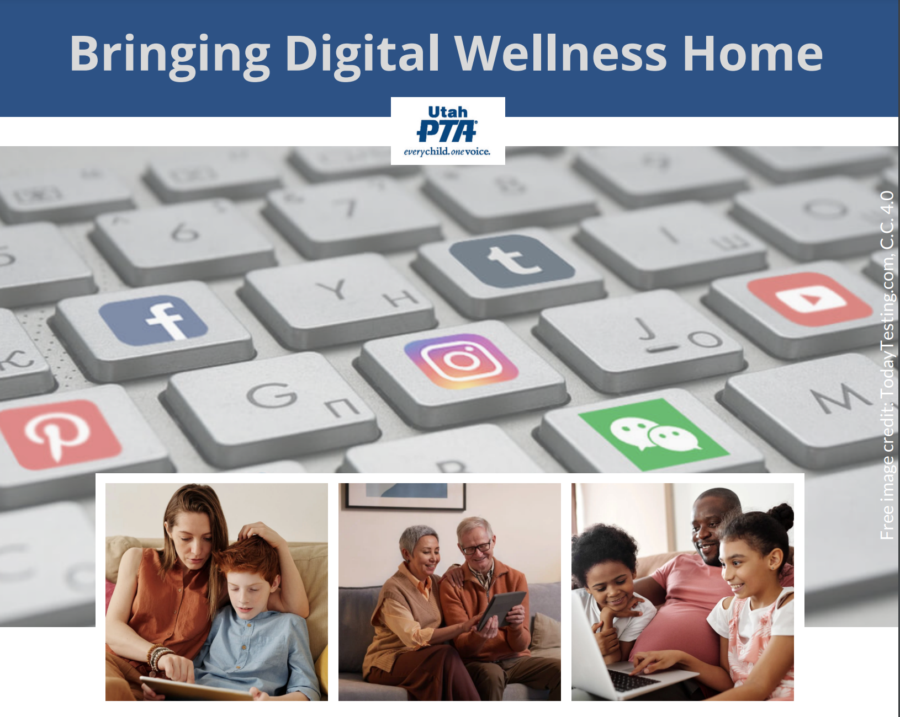

**PTA's Bringing Digital Wellness Home Series**

**Winter 2022**

**"Stories Connect People" Activities**

"The closest distance between two people is a story." -Jared Stewart

We are all experiencing the impacts of a culture of division. Even before the days of the digital world, the divide that existed between generations was real, and technology has the possibility to deepen that divide. But we can be deliberate about bridging it.

It's important to have specific conversations about technology, in an ongoing way, within your family (or classroom, or youth group, etc.) This is true with adults as well (e.g., creating and revisiting Communications Charters [here's a family version of a communications charter that could be adapted for a work setting] https://docs.google.com/spreadsheets/d/11zDrV4bwSZGxML2MzGi_YqvLiZI23PmRrNBEy7BD3nA/edit?usp=sharing [Adapted from a template created for the DWI Digital Wellness Certification course: https://www.digitalwellnessinstitute.com/

)

AND it's also important to just connect with each other as humans. Across generational divides, political divides, and so forth.

One key way to do this is to share and listen to each others' stories. Not with the intent to change anyone's mind about anything, but to connect around our shared humanity by sharing individual experiences around things like weather, nature, food, school, etc.

Below are some examples of *Stories Connect People* activity question prompts that we have used. You could easily come up with your own as well. When do do a formal activity, let everyone have equal time in sharing (no more, no less) and include guidelines about no cross-talk so that everyone has a chance to be heard without interruptions, commentary from others, etc.** [Guidlines we have used in our activities can be found at the bottom of this document.]

An organization called Tribarly has done over a decade and a half of work observing the impact that simply connecting around stories can do for families and work groups. We invite you to give this a try in your own home or workplace or classroom or other group setting.



Share about someone who has had a personal impact on you.

OR

Share about someone you don’t know whose story has impacted you.

Share one of your earliest memories

OR

Share a memorable school experience

What’s your favorite season and why?

OR

What’s a favorite summer activity?

What is something many people don’t know about you?

OR

 What’s something other people might share about you?

What was a favorite class you took (and why?)

 OR

 What is a favorite book or movie (and why)?

What is a memorable experience with weather

OR

Share about a favorite nature experience or location

It can brighten my day when _________

OR

I have a hard time re-centering when __________.

Share a favorite childhood activity.

OR

 Share about a memory with a childhood buddy.

What is about a fun meal tradition in your family

OR

 Share about the most unusual thing you have eaten

Who is someone who has had a personal impact on you and why?

 OR

Who is someone you don’t know whose story has impacted you and why?

Share about a memorable DIY project

OR

Share about a new skill you would like to learn

**The following activities involve a little more time and focus. They start with 1-2 minutes for each person to think and write their answers to the first question, and then a 2-3 minute share for each person in the group.**

[Think/Write] List 2-3 unusual experiences people could ask you about.

[Share] Share a story about one of the experiences..

[Think/Write] Pick one item on your bucket list.

[Share] Share your list and then share a story behind why that dream is on your bucket list?

[Think/Write] List 2-3 items that you are passionate about

[Share] Share a story about one of these things.

[Think/Write]: List 2-3 of your dreams.

[Share] Share a story about one of your dreams.

[Think/Write] List 2-3 things for which you are known.

[Share] Tell a story about one of them.

**This last activity is the most time-intensive of all, but can be very valuable in creating a sense of care and helpfulness in your family/group. See Barbara Sher's TED talk that illustrates the power of this principle. [It takes her a while to get to her point. Stick with it. It's worth the 21+ minutes!] https://www.tedxprague.cz/en/videa/isolation-is-the-dream-killer-not-your-attitude-barbara-sher**

Ask for help from your family/circle of support/discussion table:

[Think/Write]: What is something you am dealing with or working on in your life with which you have hit a barrier or wall?

[Share & Listen]: What help could you use from others on something? “I could use some ideas on….” [This activity opens up discussion for people to share/brainstorm ideas around what you are working on...a chance for you to listen to their ideas, even if not all will be relevant. The format could either be a timed share from each person at the table, or an open discussion. The former ensures that everyone at the table gets an opportunity to participate.]

Ground rules for this activity are the reverse of the previous activities. In this case, the person who asks the question just listens to input, without interrupting, even if what is shared from others isn't really helpful.

The Think/Write portion again takes 1-2 minutes and the sharing/listening portion lasts for 5-10 minutes, depending on the time you have and how many people are at each table/in each breakout.

**\*\*Engagement Guidelines for Stories Connect People activity**

* Keep groups to about 4-6 people. (If you are doing this in your family, decide how much time you want to spend with this activity and work backwards, based on the number of people in your family, with the amount of time for the Think/Write and Share portions. For example, if you have a family of six and you want to spend 15 minutes on the activity, after a minute or so on instruction, give each person 1-2 minutes to write, and then give each person 2 minutes to share (for the Stories Connect People activity).
* Give individuals 1-2 minutes to Think/Write.
* Give each person 1-2 minutes to share (2-3 minutes is ideal). Use a timer.
* Everyone gets the full time, no less, no more. The idea here is to give everyone equal opportunity to have a voice. If someone finishes early, others can ask them a question so they can share more and use up the rest of their time. Only ask questions for clarification and follow-up -- no commenting or advice-giving. Just questions!
* Follow alphabetical order of first names for ease of flow (or you can go backwards with names or forward or backward with birth months or birth days of the month).
* When the timer goes off, even if the one sharing is in the middle of a sentence, that person says, “And, I’m done!” so everyone has equal time and the flow is not interrupted. Allow for about 5-10 seconds for the next person to start.
* It is ideal to assign a timekeeper (and then when the timekeeper is sharing, someone else can time).